**Name: Maruti Pundlik Dalvi**

**Class: FYMCA Sem II**

**Subject: NS3 Lab**

**Seat Number: 2012202**

**Roll Number: MCA2024096**

1. **Write a program to animate the wireless topology with using ns3 and netanim.**

**1. Open Terminal and Navigate to NS-3 Folder**

cd ~/ns-allinone-3.35/ns-3.35

**2. copy star.cc from examples folder and paste in scratch folder**

**3. modify the star.cc in scratch folder**

**a. add header file**



**b. add simulation setup and nodes**

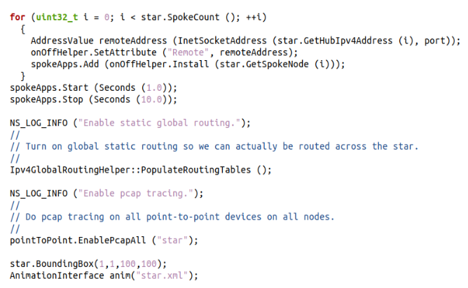

**c. Run the Simulation with PCAP Enabled**

./waf --run "scratch/star_topology"

**d. open netanim using following command**

./NetAnim

**e. In NetAnim Software select star.xml file and run the simulation**

**OUTPUT:**

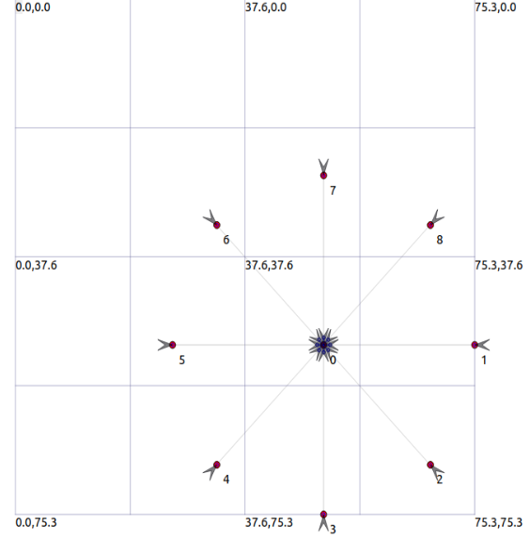

1. **Analyze the network traffic using wireshark on star topology with 16 spokes.**

**1. Open Terminal and Navigate to NS-3 Folder**

cd ~/ns-allinone-3.35/ns-3.35

**2. copy star.cc from examples folder and paste in scratch folder**

**3. modify the star.cc in scratch folder**

**a. add header file**



**b. add 16 spokes**

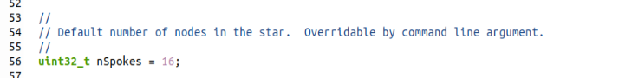

**c. add simulation setup and nodes**



**d. Run the Simulation with PCAP Enabled**

./waf --run "scratch/star_topology"

**e. open netanim using following command**

./NetAnim

**d. In NetAnim Software select star.xml file and run the simulation**

**f. to analyse traffic using wireshark write followingcommand**

wireshark star-16-0.pcap

